|  |  |  |
| --- | --- | --- |
| #1 | **Multi Triangle/Pyramid Shadows** |  |
|  |  | This pattern was chosen based on my interest in ancient Egypt and pyramid designs in general. The goal was to create a basic triangle based recursive pattern, however I would like to improve on the program and create a full 3D pyramid by implementing P3D in processing to create a pyramid shadow that subdivides into a series of smaller triangular shadows until the base case is reached. For the program I implemented triangle shadows are formed left and right from the original triangle recursively. |
| Link | https://www.google.ca/search?rlz=1C1CHBF_enCA814CA814&biw=1604&bih=792&tbm=isch&sa=1&ei=5celW5nUMvvL0PEPs_yUgA4&q=triangle+shadow&oq=triangle+shadow&gs_l=img.3..35i39k1l2j0l5j0i7i30k1l2j0i5i30k1.18648.18648.0.19406.1.1.0.0.0.0.71.71.1.1.0....0...1c.1.64.img..0.1.70....0.QTWr2yERMWs#imgdii=lUSsyZA38z9bhM:&imgrc=0eHvgwvMMdAFfM: |  |

|  |  |  |
| --- | --- | --- |
| #2 | Recursive Windows/Mirrors |  |
|  |  | The second design I decided on was a recursive pattern of emerging windows, which can be emulated both in nature and computers. With regards to computers a user can have multiple virtual machines running within the host OS and in nature this pattern can be seen by projecting a mirror into another mirror where a pattern of nearly infinite mirrors can be seen. For simplicity and function I have limited the number of recursive windows being projected, with limitations based on pixels in processing. |
| Link | https://hirshhorn.si.edu/kusama/infinity-rooms/ |  |

1. **Name your Processing files as recursiveA_yourLastname_firstnameInitial.pde and recursiveB_yourLastname_firstnameInitial.pde.**
   1. **Describe your design rules with images showing the breakdown of each recursive process (example below) for your first work.**

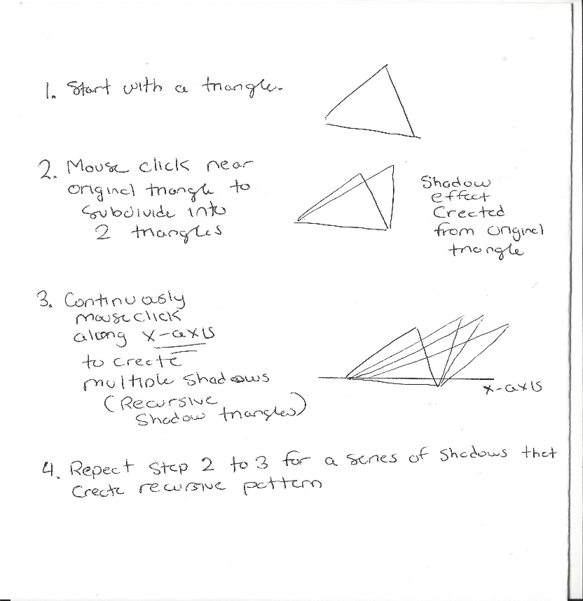

* **Attach minimum two screen shots of your work showing interactive change.**

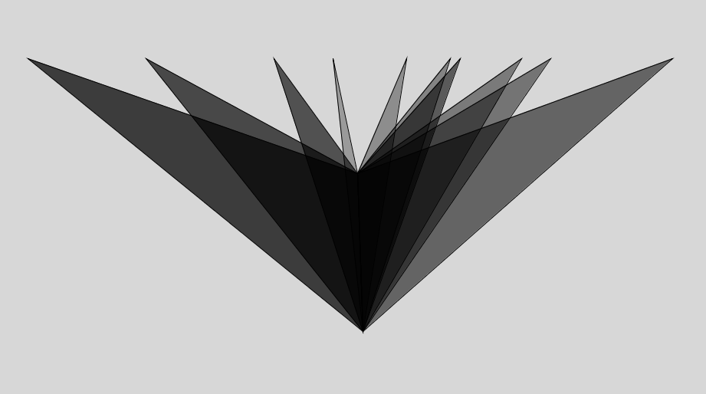

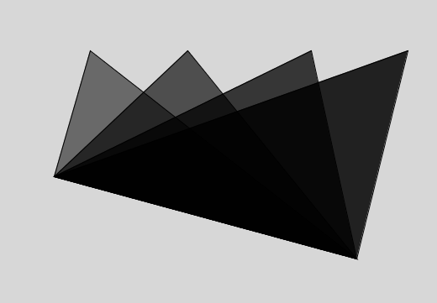**Figure 1&2. Triangle Shadow Recursive**

* 1. **Describe your design rules (example below) for your second work (similar to your first work).**

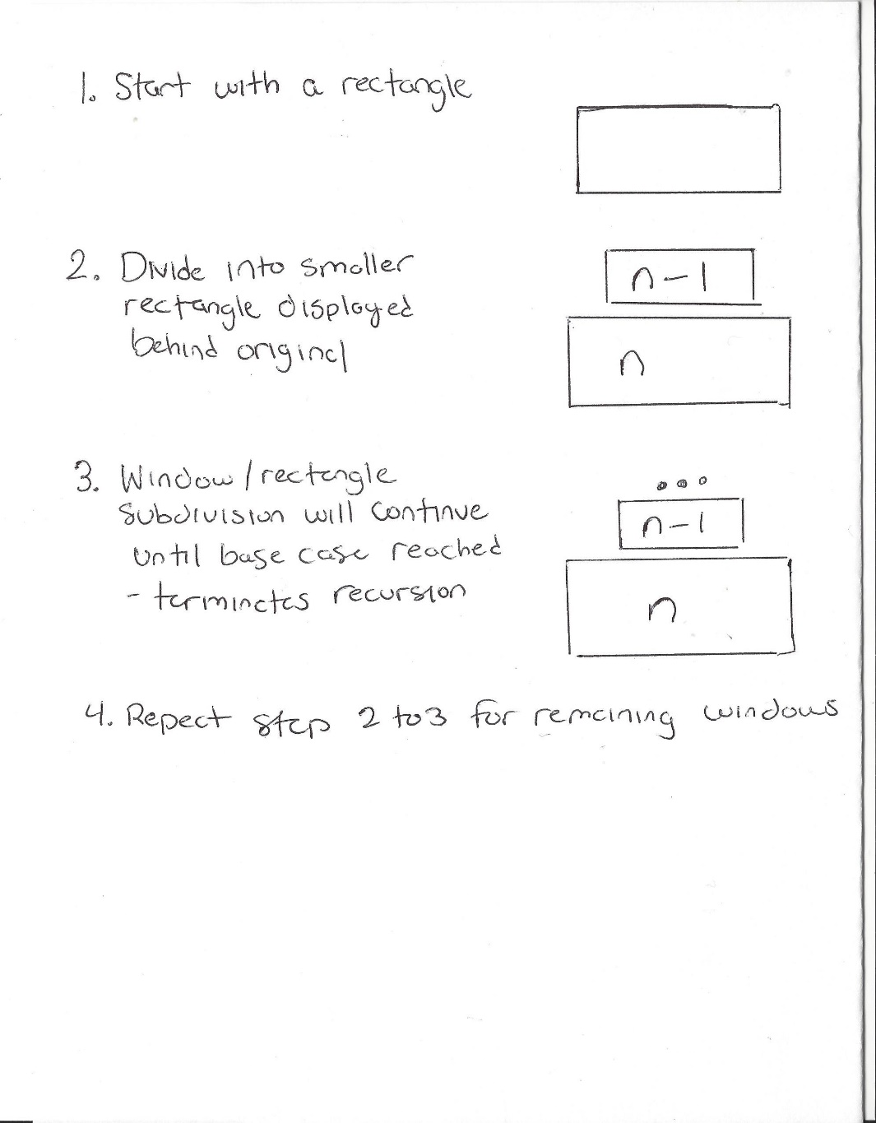

* Attach minimum two screen shots of your work showing interactive change.

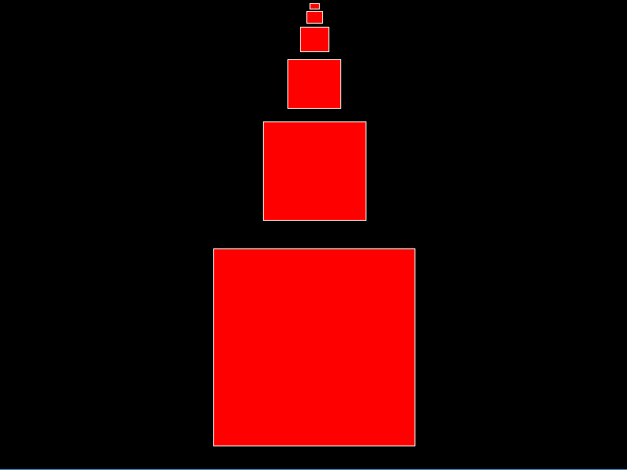

Figure 2. Recursive Windows

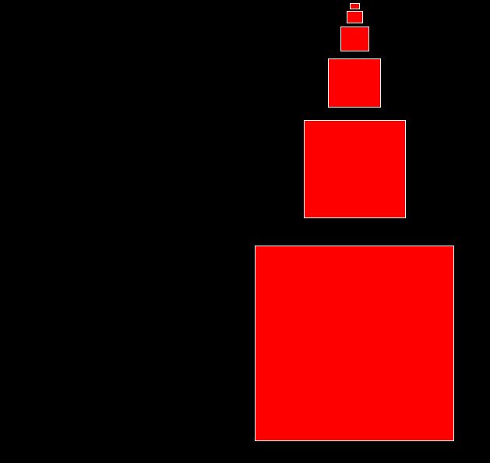

Figure 3. Recursive Windows Transformation